ALGORITHMS
MILESTONE Q1

22k-4004 Aarib Ahmed
22k-4079 Partham Kumar
22k-4080 Arham Hussain Khan

AI SEC (B)
Q1
a)
1)-
Function sol(arr, low, high)
if low == high then
return (arr[low], arr[low])
else if high == low + 1 then
if arr[low] > arr[high] then
return (arr[low], arr[high])
else
return (arr[high], arr[low])
else
mid = (low + high) // 2
(max1, min1) = sol(arr, low, mid)
(max2, min2) = sol(arr, mid+1, high)
return (max(max1, max2), min(min1, min2))

2)
The divide-and-conquer algorithm divides the array into two halves, performs recursive comparisons, and then combines the results. Let T(n)T(n)T(n) represent the number of key comparisons needed for an array of size nnn.
- When the array is divided into two halves, the two recursive calls take T(n/2)T(n/2)T(n/2) comparisons each.
- To combine the results, two comparisons are made (one to compare the minimums and one to compare the maximums).

Relation is:
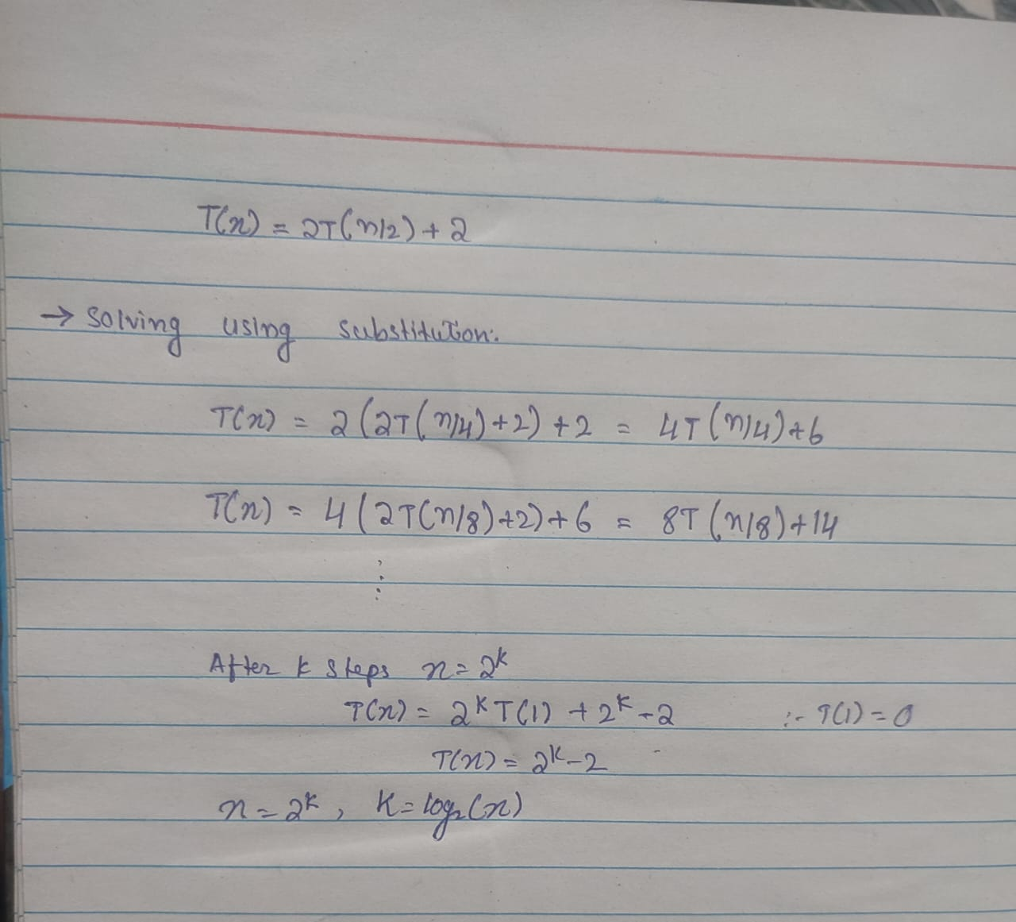

3)
- Divide-and-Conquer Algorithm:
Number of comparisons: n−2
Time complexity: O(n)
- Brute-Force Algorithm:
Number of comparisons: To find the maximum element, you need n−1comparisons. To find the minimum element, you need another n−1comparisons. This results in a total of 2n−2 comparisons.
Time complexity: O(n)
- Efficiency: The divide-and-conquer algorithm is more efficient because it makes n−2n - 2n−2 comparisons, while the brute-force algorithm makes 2n−22n - 22n−2 comparisons. The divide-and-conquer approach requires half as many comparisons as the brute-force method.
- Both algorithms have a linear time complexity of O(n)O(n)O(n), but the divide-and-conquer approach is more efficient in practice due to fewer key comparisons.
B
1)
function sol(a, n):
if n == 0:
return 1
if n == 1:
return a

if n is even:
halfPower = sol(a, n // 2)
return halfPower * halfPower

else:
halfPower = sol(a, (n - 1) // 2)
return halfPower * halfPower * a

2)
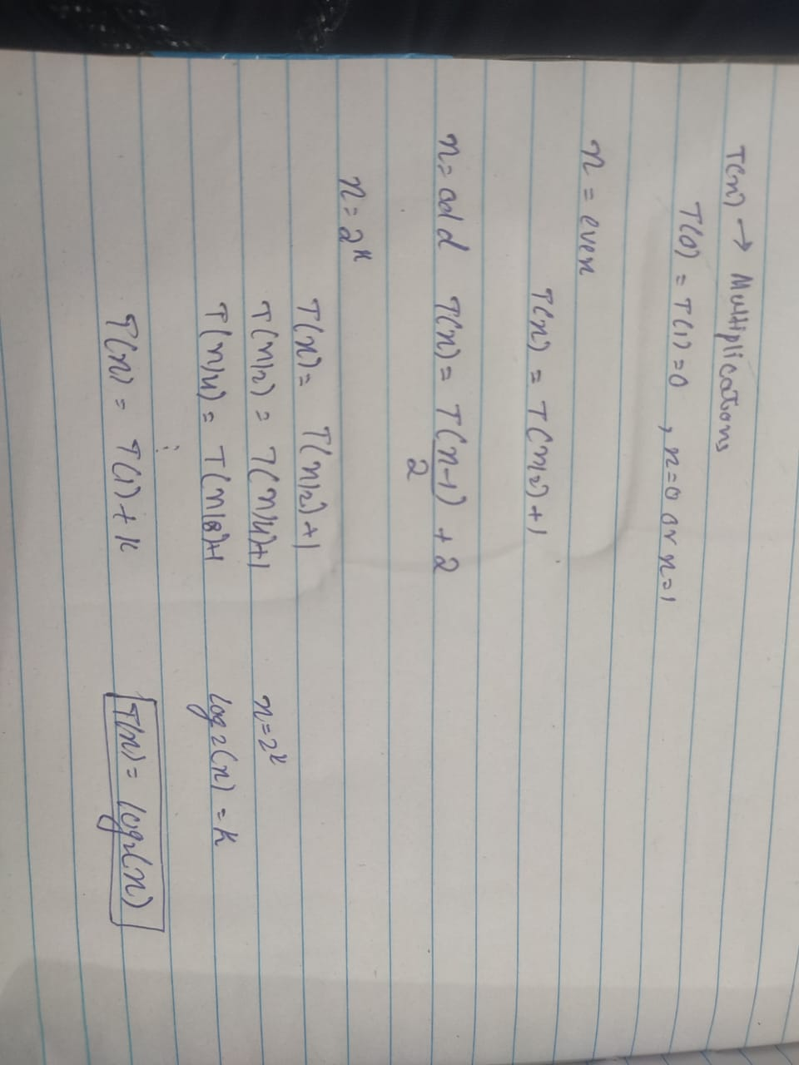

3)
• Divide-and-Conquer Algorithm:
Number of multiplications: O(logn)
The divide-and-conquer method reduces the exponent n by half at each step, leading to logarithmic time complexity.
• Brute-Force Algorithm:
Number of multiplications: To compute a^n, the brute-force approach multiplies aaa by itself n−1times, resulting in n−1multiplications.
Time complexity: O(n).

Q1 c): Merge Sort (Inversion Count)
#include <iostream>
#include <vector>
using namespace std;

// Merging two sorted arrays and counting the inversions
long long mergeAndCount(vector<double>& A, int left, int mid, int right) {
int n1 = mid - left + 1;
int n2 = right - mid;

// Create temporary arrays
vector<double> L(n1), R(n2);

// Copy data to temp arrays L[] and R[]
for (int i = 0; i < n1; i++)
L[i] = A[left + i];
for (int i = 0; i < n2; i++)
R[i] = A[mid + 1 + i];

// Merge the temp arrays back into A[left..right]
int i = 0, j = 0, k = left;
long long inversions = 0;

while (i < n1 && j < n2) {
if (L[i] <= R[j]) {
A[k++] = L[i++];
} else {
A[k++] = R[j++];
// Count inversions, because all remaining elements in L are greater than R[j]
inversions += (n1 - i);
}
}

// Copy the remaining elements of L[], if there are any
while (i < n1) {
A[k++] = L[i++];
}

// Copy the remaining elements of R[], if there are any
while (j < n2) {
A[k++] = R[j++];
}

return inversions;
}

// Divide and conquer method to sort the array and count inversions
long long mergeSortAndCount(vector<double>& A, int left, int right) {
long long inversions = 0;
if (left < right) {
int mid = left + (right - left) / 2;

// Count inversions in the left half and right half
inversions += mergeSortAndCount(A, left, mid);
inversions += mergeSortAndCount(A, mid + 1, right);

// Count the inversions during the merge process
inversions += mergeAndCount(A, left, mid, right);
}
return inversions;
}

int main() {
int n;
cout << "Enter the size of the array (at least 10): ";
cin >> n;

if (n < 10) {
cout << "Please enter a size of at least 10." << endl;
return 1;
}

vector<double> A(n);
cout << "Enter " << n << " real numbers: ";
for (int i = 0; i < n; i++) {
cin >> A[i];
}

long long inversions = mergeSortAndCount(A, 0, n - 1);

cout << "The number of inversions is: " << inversions << endl;
cout << "The sorted array is: ";
for (double num : A) {
cout << num << " ";
}
cout << endl;

return 0;
}

OUTPUT:
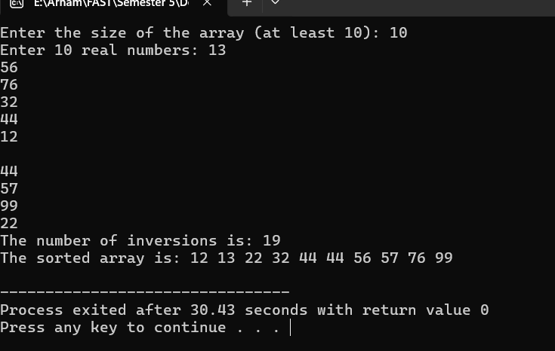
Q1 D): Quick-Sort Algorithm
#include <iostream>
#include <vector>
using namespace std;

int partition(vector<double>& A, int low, int high) {
double pivot = A[high]; // choosing the last element as the pivot
int i = low - 1; // Index of the smaller element

for (int j = low; j < high; j++) {
if (A[j] <= pivot) {
i++;
// Swap A[i] and A[j]
swap(A[i], A[j]);
}
}

swap(A[i + 1], A[high]);
return i + 1;
}

void quicksort(vector<double>& A, int low, int high) {
if (low < high) {

int pivotIndex = partition(A, low, high);

quicksort(A, low, pivotIndex - 1); // Before pivot
quicksort(A, pivotIndex + 1, high); // After pivot
}
}

int main() {
int n;
cout << "Enter the size of the array (at least 10): ";
cin >> n;

if (n < 10) {
cout << "Please enter a size of at least 10." << endl;
return 1;
}

vector<double> A(n);
cout << "Enter " << n << " real numbers: ";
for (int i = 0; i < n; i++) {
cin >> A[i];
}

quicksort(A, 0, n - 1);

cout << "The sorted array is: ";
for (double num : A) {
cout << num << " ";
}
cout << endl;

return 0;
}
OUTPUT:
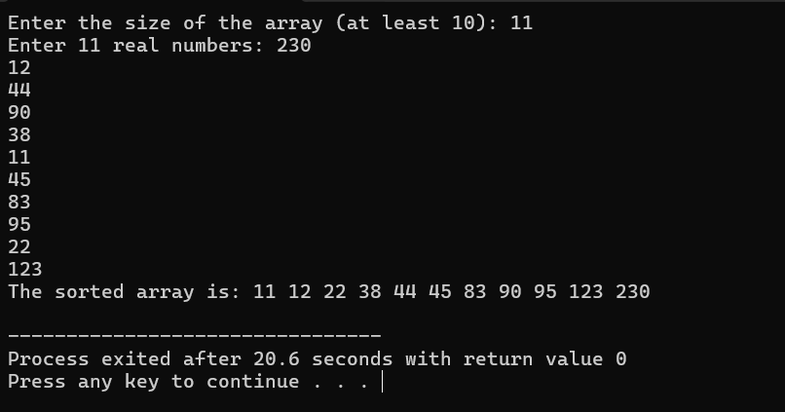
i): Worst Case Time complexity of Quick-Sort Algorithm is O(n^2). While Best Case Time complexity is O(n logn).

Q1 e): Closest pair problem (One- Dimensional Version)
#include <iostream>
#include <vector>
#include <algorithm>
#include <cmath>
#include <limits>

using namespace std;

double minDistance(double d1, double d2) {
return (d1 < d2) ? d1 : d2;
}

// Brute force approach to find the closest pair in a small set
double bruteForceClosestPair(const vector<double>& A, int left, int right) {
double minDist = numeric_limits<double>::max();
for (int i = left; i < right; i++) {
for (int j = i + 1; j <= right; j++) {
minDist = min(minDist, abs(A[i] - A[j]));
}
}
return minDist;
}

double closestPairDivideAndConquer(const vector<double>& A, int left, int right) {
// Base case: if there are 2 or 3 elements, use brute force
if (right - left <= 2) {
return bruteForceClosestPair(A, left, right);
}

int mid = left + (right - left) / 2;

double dLeft = closestPairDivideAndConquer(A, left, mid);
double dRight = closestPairDivideAndConquer(A, mid + 1, right);

// Find the minimum distance from the left and right sides
double d = minDistance(dLeft, dRight);

// Combine step: Check the closest pair that crosses the middle
double crossMinDist = abs(A[mid] - A[mid + 1]);

return minDistance(d, crossMinDist);
}

int main() {
int n;
cout << "Enter the size of the array (at least 10): ";
cin >> n;

if (n < 10) {
cout << "The size of the array must be at least 10." << endl;
return 1;
}

vector<double> A(n);
cout << "Enter " << n << " real numbers: ";
for (int i = 0; i < n; i++) {
cin >> A[i];
}

sort(A.begin(), A.end());

double closestDist = closestPairDivideAndConquer(A, 0, n - 1);

cout << "The closest distance between two numbers is: " << closestDist << endl;

return 0;
}
OUTPUT:
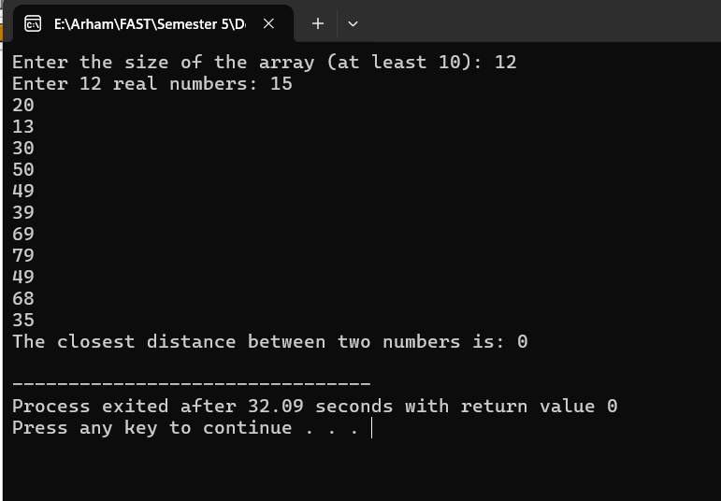
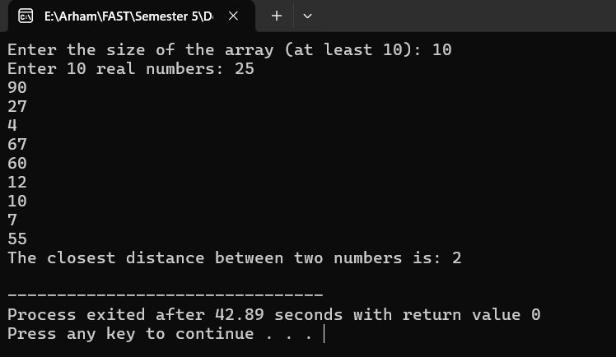

i): Efficiency Class
The efficiency of this algorithm is O(n logn) similar to that of merge sort algorithm. This is due to recursive division of array and O(n) times in the merging part.
ii): Is this Algo Good enough?
This divide-and-conquer algorithm is not necessarily optimal compared to simple sorting-based approach.
In sorting-based approach, you can simply sort the array in O(nlogn) times and then search through the array to find the smallest distance between consecutive elements in O(n) times. This approach is conceptually simple to implement.

DAA PROJ QS 1 PART F G H
QS 1 PART F

#include <iostream>
#include <vector>

using namespace std;

// Function to find the peak element in array using divide and conquer
int findPeak(const vector<int>& arr, int low, int high) {
int mid = low + (high - low) / 2;

//if the mid element is greater than both its neighbors then it's the peak
if ((mid == 0 || arr[mid - 1] <= arr[mid]) && (mid == arr.size() - 1 || arr[mid + 1] <= arr[mid])) {
return mid;
}

//if the element on the left of mid is greater then the peak lies on the left side
if (mid > 0 && arr[mid - 1] > arr[mid]) {
return findPeak(arr, low, mid - 1);
}

//if the element on the right of mid is greater then the peak lies on the right side
return findPeak(arr, mid + 1, high);
}

int main() {
int n;
cout << "Enter the size of the array (minimum 10): ";
cin >> n;
if (n < 10) {
cout << "The minimum Array size is 10" << endl;
return 1;
}
vector<int> arr(n);
cout << "Enter " << n << " distinct elements of the unimodal array (values increase then decrease):" << endl;
for (int i = 0; i < n; ++i) {
cin >> arr[i];
}
int peakIndex = findPeak(arr, 0, n - 1);
cout << "The peak element is at index " << peakIndex << " with value " << arr[peakIndex] << "." << endl;
return 0;
}

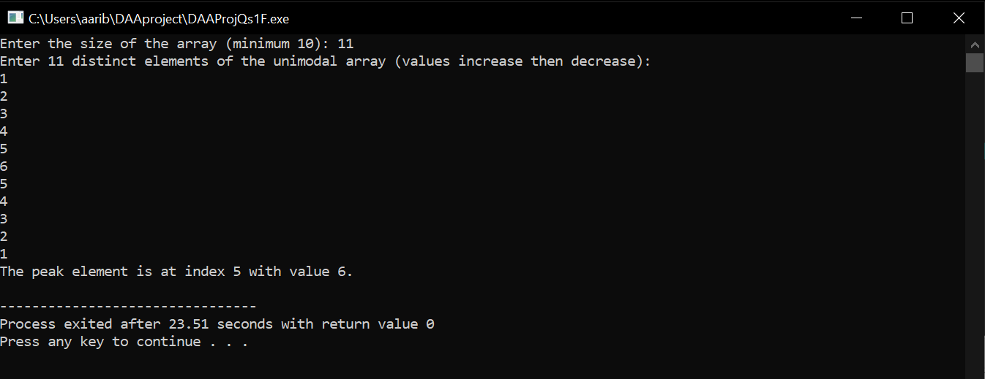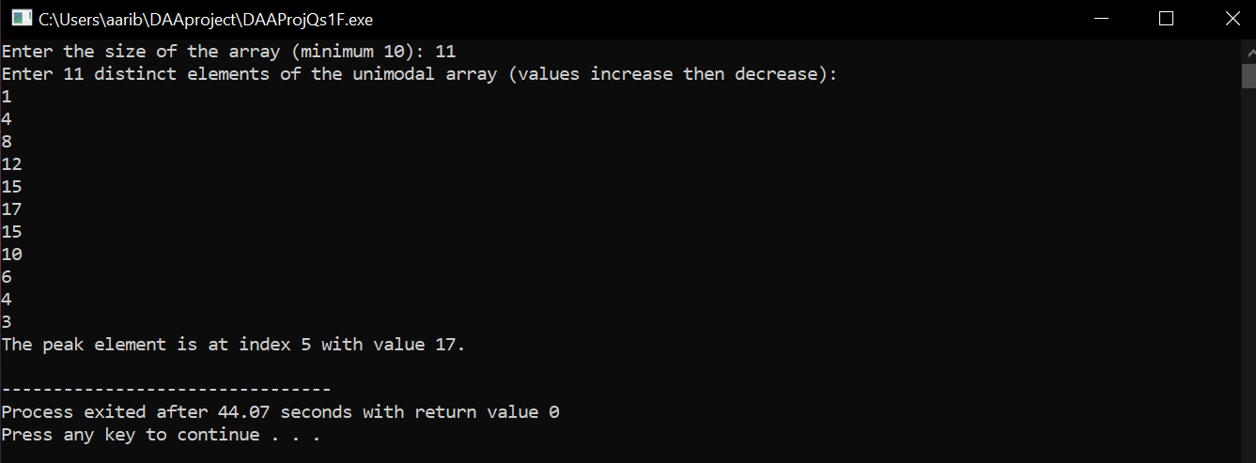

QS 1 PART G

#include <iostream>
#include <vector>
#include <limits.h>
using namespace std;
struct Result {
int buyDay;
int sellDay;
int maxProfit;
};

//function to find the minimum price index in the left half
int findMinIndex(const vector<int>& prices, int start, int end) {
int minIndex = start;
for (int i = start + 1; i <= end; ++i) {
if (prices[i] < prices[minIndex]) {
minIndex = i;
}
}
return minIndex;
}

//function to find the maximum price index in the right half
int findMaxIndex(const vector<int>& prices, int start, int end) {
int maxIndex = start;
for (int i = start + 1; i <= end; ++i) {
if (prices[i] > prices[maxIndex]) {
maxIndex = i;
}
}
return maxIndex;
}

//DC func to find the best buy,sell days
Result findBestProfit(const vector<int>& prices, int start, int end) {
//Base case when only one day
if (start == end) {
return {start, start, 0}; // No profit can be made on one day
}

int mid = (start + end) / 2;
// Recursin to find best profit in left and right halfs
Result leftResult = findBestProfit(prices, start, mid);
Result rightResult = findBestProfit(prices, mid + 1, end);

//finding the best buy day in left half and the best sell day in right half
int minLeftIndex = findMinIndex(prices, start, mid);
int maxRightIndex = findMaxIndex(prices, mid + 1, end);
int crossProfit = prices[maxRightIndex] - prices[minLeftIndex];

Result bestResult = leftResult;
if (rightResult.maxProfit > bestResult.maxProfit) {
bestResult = rightResult;
}
if (crossProfit > bestResult.maxProfit) {
bestResult = {minLeftIndex, maxRightIndex, crossProfit};
}
return bestResult;
}

int main() {
int n;
cout << "Please enter the number of days min 10 ";
cin >> n;
if (n < 10) {
cout << "Please enter minimum 10 days of stock prices" << endl;
return 1;
}

vector<int> prices(n);
cout << "please enter the stock prices for each day:" << endl;
for (int i = 0; i < n; ++i) {
cin >> prices[i];
}

Result result = findBestProfit(prices, 0, n - 1);

if (result.maxProfit > 0) {
cout << "Buy on day " << result.buyDay + 1 << ",and sell on day " << result.sellDay + 1 << endl;
cout << "Maximum profit is " << result.maxProfit << endl;
} else {
cout << "unfortunately no profit can be made " << endl;
}

return 0;
}

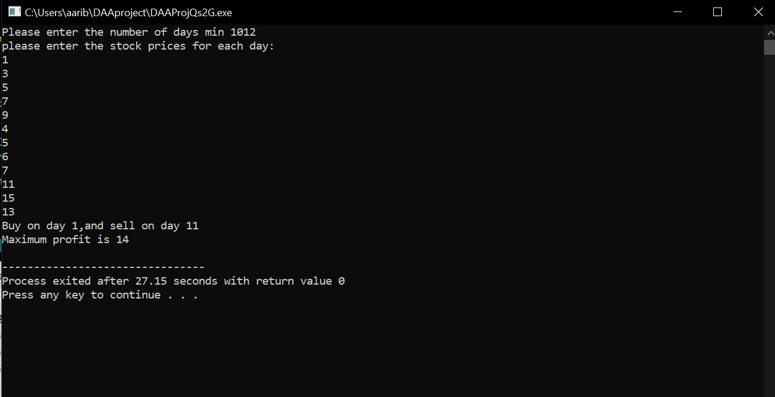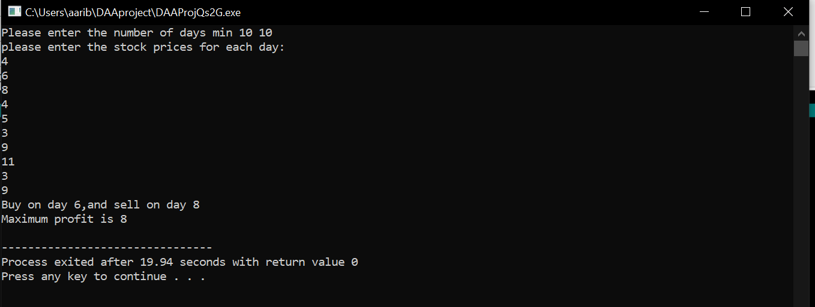
QS 1 PART H
INVERSIONS PROBLEM, PROBLEM 2
#include <iostream>
#include <vector>

using namespace std;

int mergeAndCountSignificant(vector<int>& data, int start, int mid, int end) {
int significantCount = 0;
int j = mid + 1;

for (int i = start; i <= mid; i++) {
while (j <= end && data[i] > 2 * data[j]) {
j++;
}
significantCount += (j - (mid + 1));
}

vector<int> merged;
int leftIdx = start;
int rightIdx = mid + 1;

while (leftIdx <= mid && rightIdx <= end) {
if (data[leftIdx] <= data[rightIdx]) {
merged.push_back(data[leftIdx]);
leftIdx++;
} else {
merged.push_back(data[rightIdx]);
rightIdx++;
}
}

while (leftIdx <= mid) {
merged.push_back(data[leftIdx]);
leftIdx++;
}

while (rightIdx <= end) {
merged.push_back(data[rightIdx]);
rightIdx++;
}

for (int i = 0; i < merged.size(); i++) {
data[start + i] = merged[i];
}

return significantCount;
}

int countSignificantInversions(vector<int>& data, int start, int end) {
if (start >= end) {
return 0;
}

int mid = start + (end - start) / 2;

int totalCount = countSignificantInversions(data, start, mid);
totalCount += countSignificantInversions(data, mid + 1, end);
totalCount += mergeAndCountSignificant(data, start, mid, end);

return totalCount;
}

int main() {
int elementCount;

cout << "Please enter the number of elements (>10) ";
cin >> elementCount;

if (elementCount < 10) {
cout << "The number of elements must be at least 10." << endl;
return 1;
}

vector<int> values(elementCount);

cout << "Please enter " << elementCount << " distinct integers:" << endl;
for (int i = 0; i < elementCount; i++) {
cin >> values[i];
}

int significantInversions = countSignificantInversions(values, 0, elementCount - 1);

cout << "Total number of significant inversions found is " << significantInversions << endl;

return 0;
}

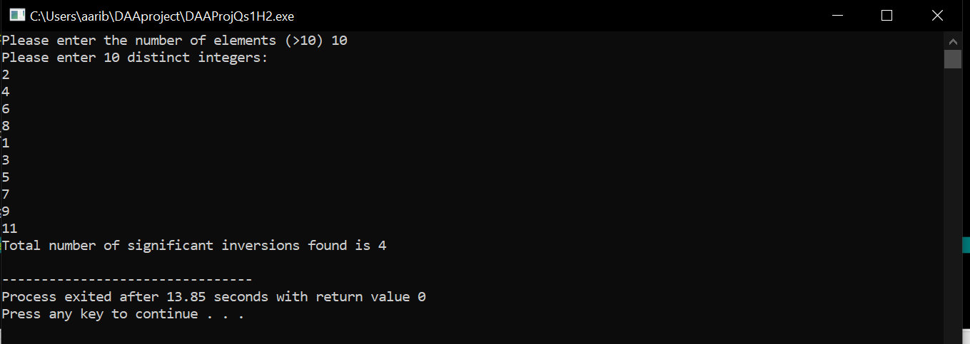

QS 1 H PART 3
BANK CARDS PROBLEM

#include <iostream>
#include <vector>
using namespace std;

bool equivalenceTester(int card1, int card2) {
return card1 == card2;
}

int countEquivalents(const vector<int>& cards, int candidate) {
int count = 0;
for (size_t i = 0; i < cards.size(); i++) {
if (equivalenceTester(cards[i], candidate)) {
count++;
}
}
return count;
}

int findMajority(vector<int>& cards, int left, int right) {
if (left == right) {
return cards[left];
}

int mid = left + (right - left) / 2;

int leftMajority = findMajority(cards, left, mid);
int rightMajority = findMajority(cards, mid + 1, right);

if (equivalenceTester(leftMajority, rightMajority)) {
return leftMajority;
}
int leftCount = countEquivalents(cards, leftMajority);
int rightCount = countEquivalents(cards, rightMajority);

int rangeSize = right - left + 1;
if (leftCount > rangeSize / 2) {
return leftMajority;
} else if (rightCount > rangeSize / 2) {
return rightMajority;
} else {
return -1;
}
}

void solveFraudDetection(vector<int>& cards) {
int n = cards.size();
int majority = findMajority(cards, 0, n - 1);

if (majority != -1 && countEquivalents(cards, majority) > n / 2) {
cout << "There is a majority card: " << majority << " with more than " << n / 2 << " occurrences." << endl;
} else {
cout << "There is no majority card." << endl;
}
}

int main() {
int n;
cout <<"CARD PROBLEM EXERCISE NUMBER 3 CHAPTER 5\n\n\n";
cout << "Please enter the number of bank cards: ";
cin >> n;

vector<int> cards(n);

cout << "Please enter the values for the bank cards: " << endl;
for (int i = 0; i < n; i++) {
cout << "Card " << (i + 1) << ": ";
cin >> cards[i];
}

cout << "Bank Cards are ";
for (size_t i = 0; i < cards.size(); i++) {
cout << cards[i] << " ";
}
cout << endl;
solveFraudDetection(cards);

return 0;
}

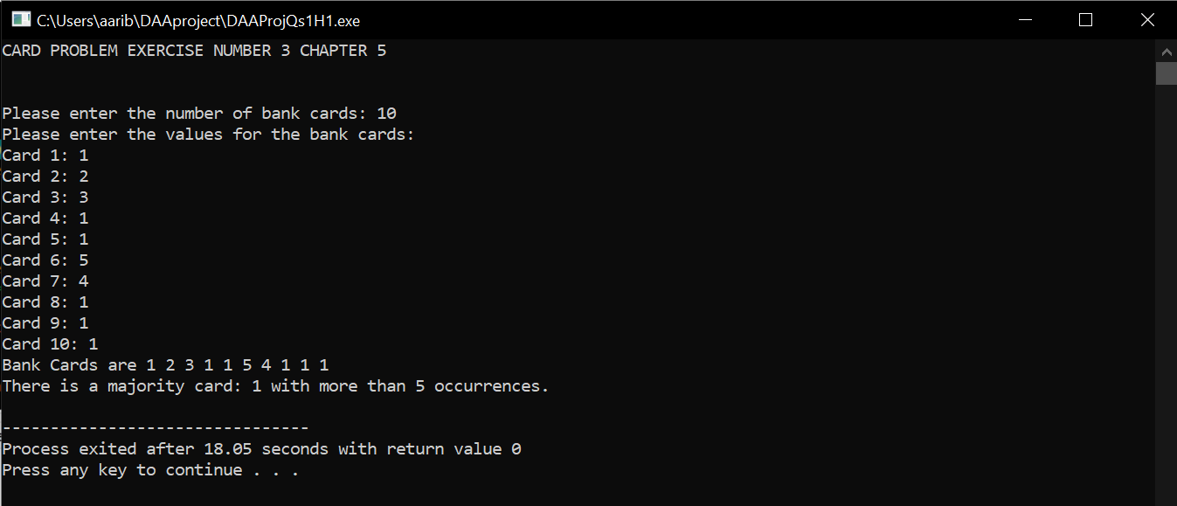

E (2)
#include <stdio.h>
#include <stdlib.h>

typedef struct {
int *heap;
int capacity;
int size;
} MinHeap;
void heapify(MinHeap* minHeap, int index) {
while (index < minHeap->size) {
int smallest = index;
int left = 2 * index + 1;
int right = 2 * index + 2;

if (left < minHeap->size && minHeap->heap[left] < minHeap->heap[smallest]) {
smallest = left;
}
if (right < minHeap->size && minHeap->heap[right] < minHeap->heap[smallest]) {
smallest = right;
}
if (smallest == index) {
break;
}
int temp = minHeap->heap[index];
minHeap->heap[index] = minHeap->heap[smallest];
minHeap->heap[smallest] = temp;
index = smallest;
}
}

MinHeap* createMinHeap(int arr[], int n) {
MinHeap* minHeap = (MinHeap*)malloc(sizeof(MinHeap));
minHeap->capacity = n;
minHeap->size = n;
minHeap->heap = (int*)malloc(minHeap->capacity * sizeof(int));

for (int i = 0; i < n; i++) {
minHeap->heap[i] = arr[i];
}

for (int i = minHeap->size / 2 - 1; i >= 0; --i) {
heapify(minHeap, i);
}

return minHeap;
}
void displayMinHeap(MinHeap* minHeap) {
for (int i = 0; i < minHeap->size; i++) {
printf("%d ", minHeap->heap[i]);
}
printf("\n");
}
void freeMinHeap(MinHeap* minHeap) {
free(minHeap->heap);
free(minHeap);
}
int main() {
int input[] = {3, 1, 6, 5, 2, 4};
int n = sizeof(input) / sizeof(input[0]);

MinHeap* minHeap = createMinHeap(input, n);
printf("Sol=");
displayMinHeap(minHeap);

freeMinHeap(minHeap);
return 0;
}
